ETiCCS Project: Resident-based HPV testing in Gondar

1. Mapping of households

The mapping of all households in the predefined community can be done in different ways, either prior to the household survey (Option A) during a reconnaissance walk where all households are enumerated by GPS, or (Option B) by use of latest Google maps and marking of all households/structures or it can be done as part of the household survey (Option C) by canvassing the predefined area and include all households.

Option A and B have the advantage of being more objective and field worker can be well instructed and monitored; option C is less time intensive but also more difficult to monitor.

The purpose of the mapping is to give every household a GPS coordinate.

1. Registering an individual household:

The community health worker, equipped with PC and GPS, finds a targeted household either via the pre-registered GPS coordinates or via identification of a household . Following exchange of courtesy and greetings, the head of household or a representative is called and the study staff introduces him/herself and asks to take/confirm the GPS coordinates of the compound (main entrance or center) on the PC (annexe 1).

3.) Enrolling an individual household

The community health worker (CHW) introduces study to the head of the household using a script (annexe 2).

With the assistance of the head of household the household composition is completed and eligible women are identified.

The following information is noted on every household member: (1) first name, (2) initials, (3) gender, (4) age in years, (5) presence, (6) residency status (3 more or more nights present), (7) relation to head of household .

4.) Enrolling eligible woman

Age-eligible who are present will be invited to take part in the survey.

The eligibility check will be completed, and the consent form will be read and signed (annexe 3).

Thereafter the contact details of the participant will be captured. This includes mailing address, physical address, national ID, telephone and an optional alternative contact person

5.) Completing socio-demographic questionnaire (optional)

6.) Collection of study sample

The participant will be explained how to self-collect a genital sample.

The CHW completes the sample requisition form on the PC (annexe 4) which contains the following information:

The date when the sample was taken, reason if not taken, a unique sample ID.

The CHW will label the collection tube and hand it over together with the brush (Evalyn™) for self collection. After use the tube with brush are stored in collection bag.

7.) Managing absent or declining woman

Eligible women who decline to take part in the survey will be asked for their reasons and a refusal form will be completed.

Eligible women who are absent during the survey visit will be informed about the study by leaving an invitation letter. An appointment for a revisit to the household will be made for the most probable date.

Annexe 1: GPS coordinates

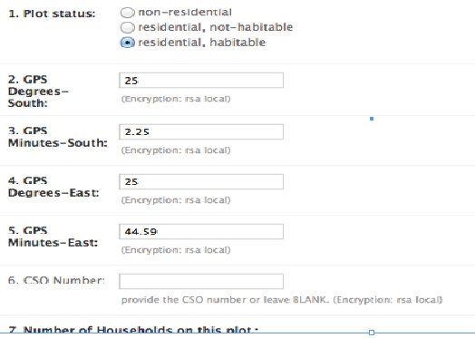

Annexe 2 : Pre Household Survey Script for household composition

COMMUNITY-WIDE HPV TESTING

THE ETiCCS PROJECT

PRE-HOUSEHOLD SURVEY SCRIPT

FOR HOUSEHOLD COMPOSITION

We are here to invite members of your household to be part of a research study.

The purpose of this study is to learn about cervical cancer in your village and ways to prevent cervical cancer in a community like yours. Cervical cancer is caused by an HPV infection and we are asking all women of this village to participate.

We would like to ask you about the number of people living here so that we can invite them to participate in a research study. We will leave a form for people who aren’t at home today to fill out if they wish so that we will know when and how we can contact them and talk about the study. We will return to the house in a few days to collect these forms. No one has to participate unless they want to.

Answering the questions about the residents of this household will take about 10 minutes.

You may feel uncomfortable answering questions about who stays in your household. You don’t have to give any information unless you want to.

There will be no direct benefit to you if you provide this information. This study will learn about ways to prevent cervical cancer, so your taking part may help other people in your community or in other similar communities.

Giving this information is your choice. If you decide to take part, you may stop at any time. You may choose not to take part without penalty to you or any effect on your medical care.

You will not be paid for answering the questions. There are no costs to you.

Your information will be given a code number. Files that link your household to the code number will only be stored in a locked cabinet. Electronic information will be stored with high-level security so that only authorized staff will be allowed to look at this information. Your household information will not be shared with anyone without your written permission, except the study team and the groups overseeing the conduct of the study (such as the Gondar University Institutional Review Board—committees that protect the safety and rights of research volunteers; the Botswana Ministry of Health; the study sponsors; or monitors checking the study). You will not be named in any publication or presentation from this study.

You can call us with any concerns or questions: *Dr. Gebehelu Abebaw (phone: XXX).* If you wish to speak with someone not directly involved in this research study about your rights, please contact Mr. XXX at the Health Research & Development Committee, Gondar University (phone:XXX).

ETiCCS Project HOUSEHOLD COMPOSITION SCRIPT

ENGLISH Script v1.0 dated December 4, 2015

Page 1 of 1

Annexe 3: Eligibility checklist:

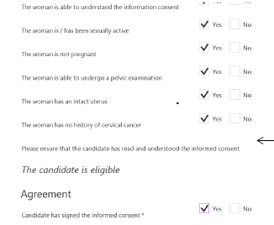

Annexe 4: Lab Requisition form